Penetration Test Report - Lab Environment

Cover Page with subject code

Field | Value
Student Name | Pentester
Student ID (USN) | 1MS19CS999
Period of Assessment | 10th May 2026 - 10th May 2026
Environment | Lab Scenario (Controlled)
Scope | 192.168.20.0/24

1. Target Summary

Target | IP | Port | Web App Name | Score Board Accessed
Target 1 | 192.168.20.47 | 52916 | Owasp Juice Shop | Yes
Target 2 | 192.168.20.113 | 53874 | Security Shepherd | Yes
Target 3 | 192.168.20.178 | 26225 | Nanocorp Bites | NA

Evidence
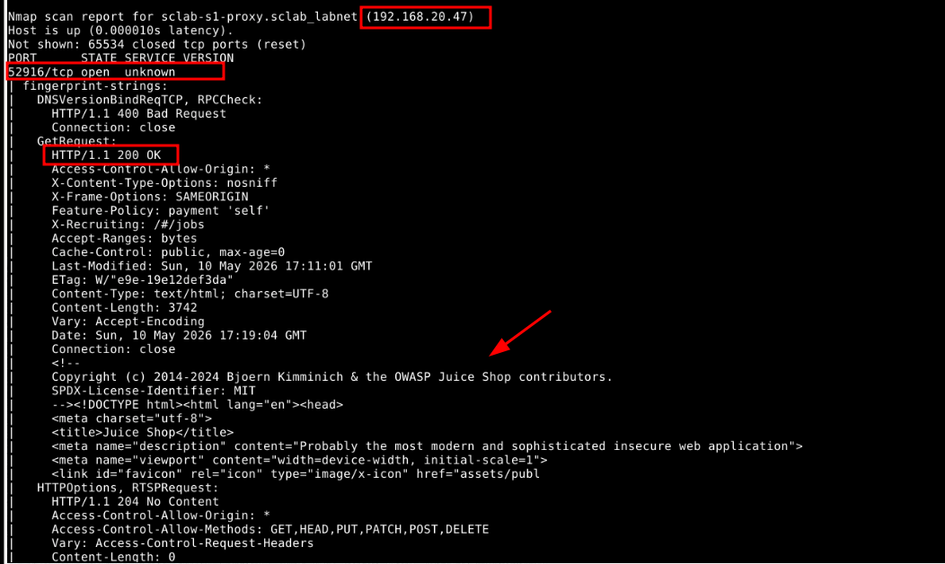
Figure 1 : Details related to target 1 from nmap scan

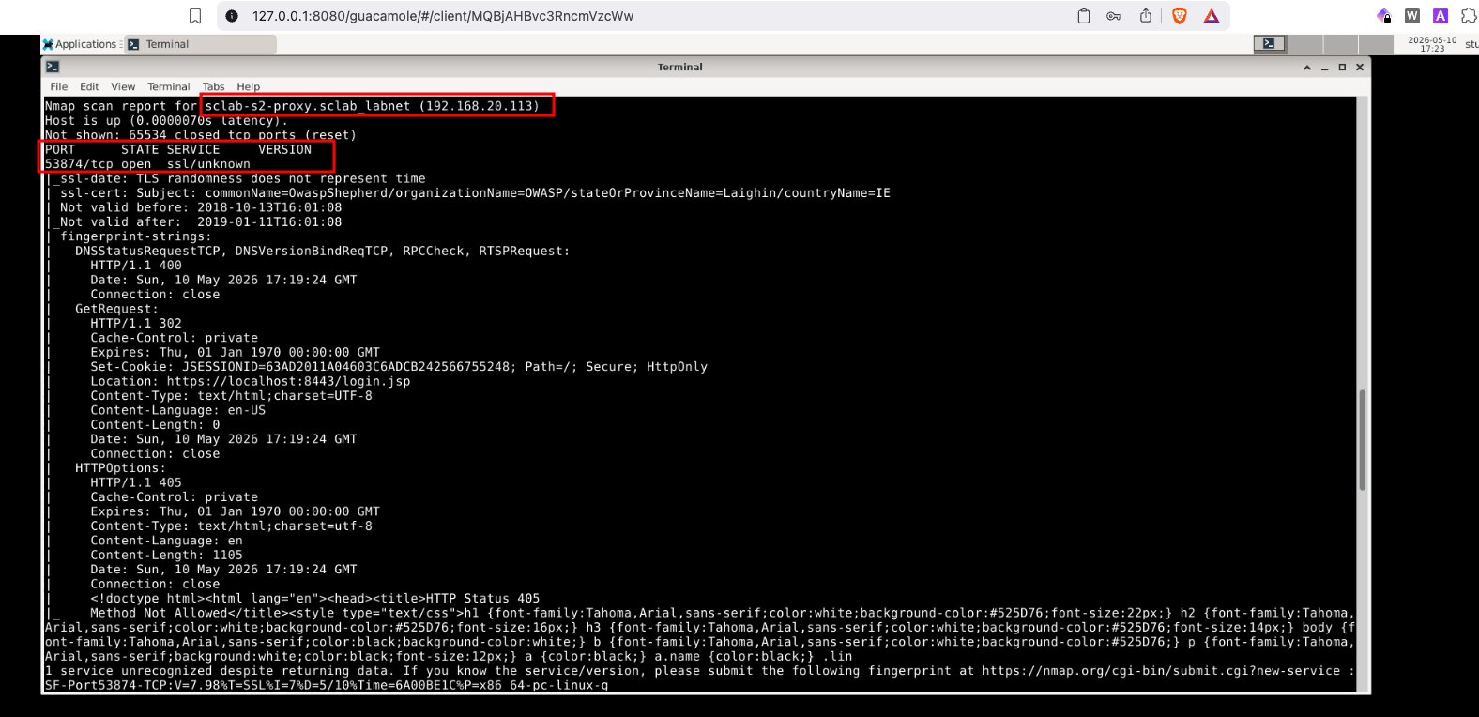
Figure 2: IP & Port Details related to Target 2

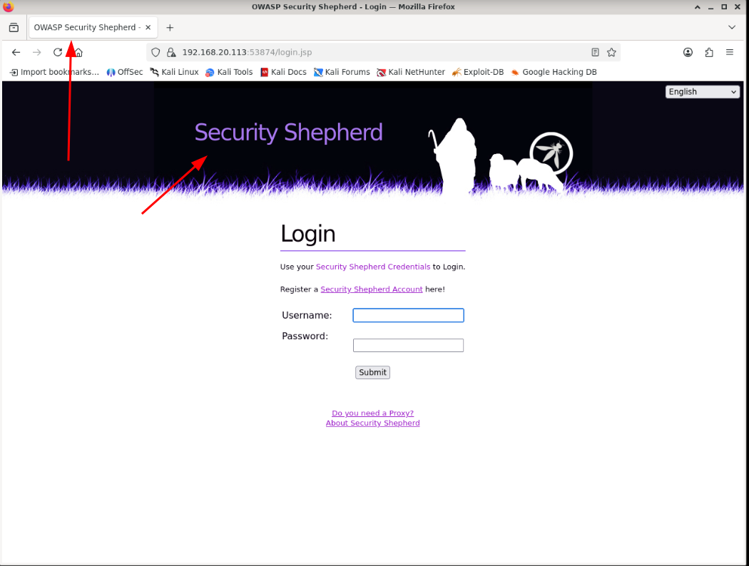
Figure 3: Target 2 on the browser - Application is Security Shepherd
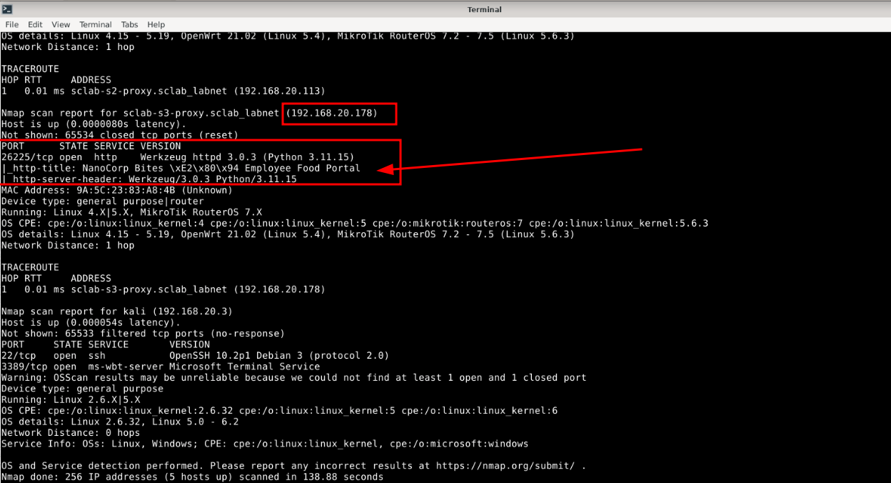
Figure 4: Target 3 - Nanocorp Bites

2. Score Board Screenshots
Note: Attach one screenshot per applicable target. Your USN must be visible in each screenshot (logged-in account or profile). Label them clearly.

OWASP Juice Shop — Score Board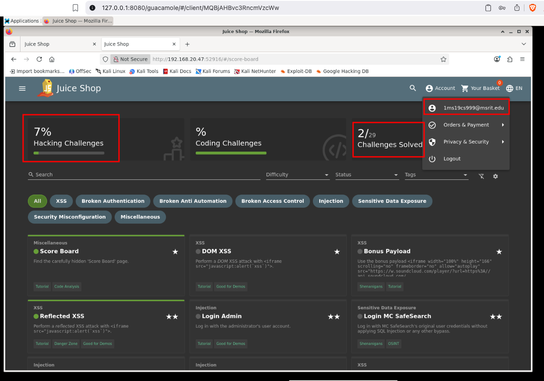

Figure 5 : OWASP Juiceshop scorecard of issues solved

Security Shepherd — Score Board

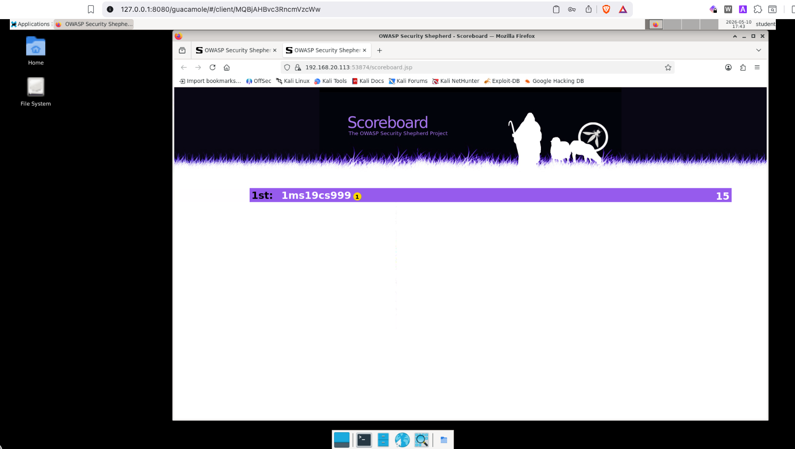

Figure 6: Score board showing logged-in USN and challenge progress for security Shepherd.

3. Findings

F-01
Title: Broken Session & Authentication Management

Target: http://192.168.20.113:53874

Description

- This vulnerability is related to broken session management on Security Shepherd wherein the application trusts user input from the cookie without appropriate validations

Steps to Reproduce
- Open inspect on the browser tab and goto storage and cookies and click on the current application.
- We see a cookie lessonComplete which is set to lessonNotComplete
- Update the cookie’s value to lessonComplete here
- Now click on Complete this lesson
- We would get the result key as output signifying this was the expectation for this vulnerability
- Copy and paste it at the top of the page and submit for the scorecard to update.

Evidence

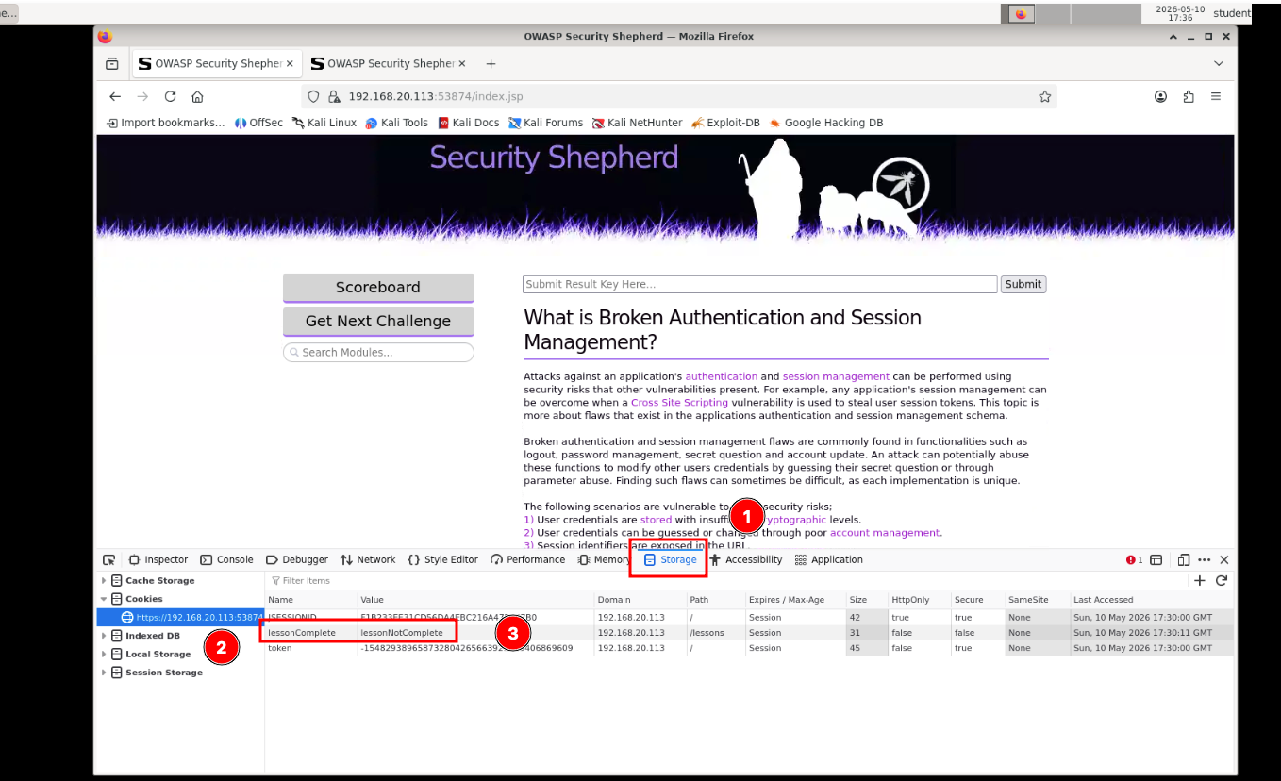
Figure 7: Exploitation - Identifying the vulnerable cookie

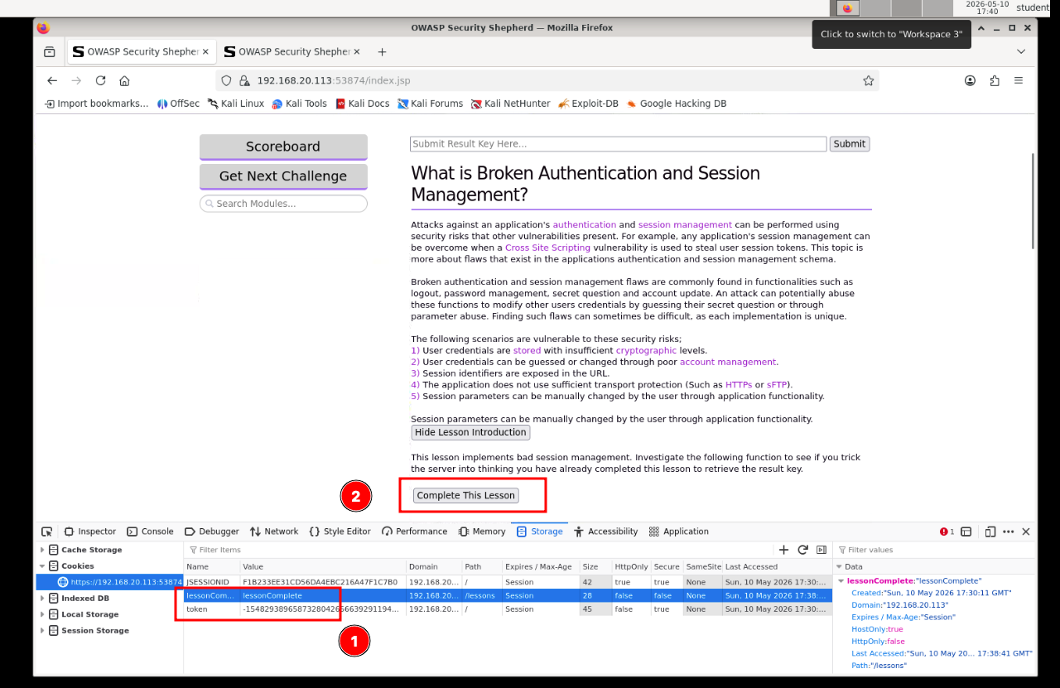
Figure 8: Update the values and Complete the Challenge

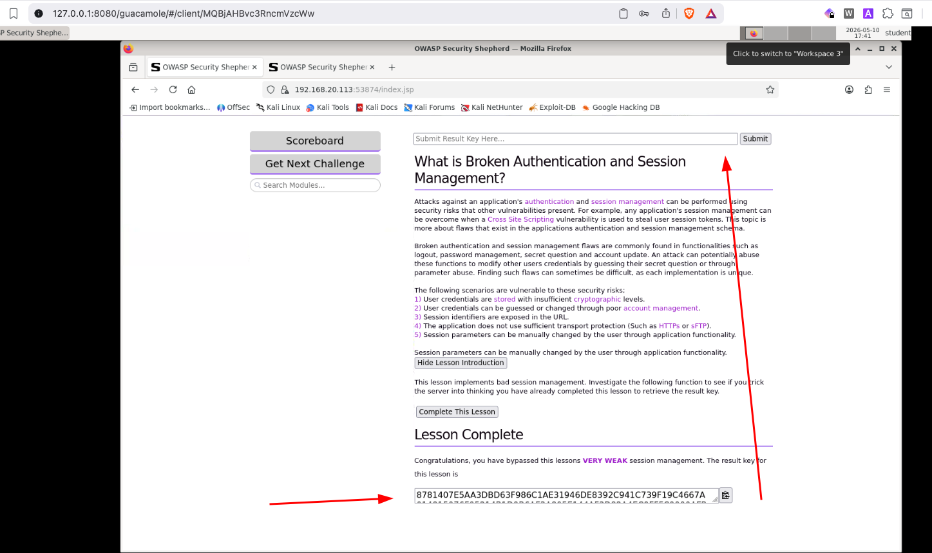
Figure 9:Exploitation successful

CVSS 3.1 Score

Field | Value
Vector Link | https://nvd.nist.gov/vuln-metrics/cvss/v3-calculator?vector=AV:N/AC:L/PR:L/UI:N/S:U/C:L/I:L/A:N&version=3.1
Base score | 5.4
Severity | Medium

Remediation

- Primary fix - Not trusting any cookies or user modifiable input

References
- https://purpleskypeter.blogspot.com/2018/04/owasp-securityshepherd-session-mgmt.html

F-02
Title: Reflected DOM XSS

Target: http://192.168.20.47:52916/

Description

This is a client Side Attack wherein a malicious actor can send a specially crafted link to a user which when clicked can lead from session hijacking to browser takeovers as well.

Steps to Reproduce
- Create an account on the app .
- Login to the account and then add items to your cart and place an order.
- After placing the order, goto order history and click on the track order icon of the placed order.
- The ID field on the URL is the vulnerable injection point which we will target and inject our payload here.
- The POC was successful with the payload used mentioned in the evidence section.

Evidence

Payload used (complete URL): http://192.168.20.47:52916/#/track-result?id=<iframe src%3D"javascript:alert(`xss`)">

Screenshot:

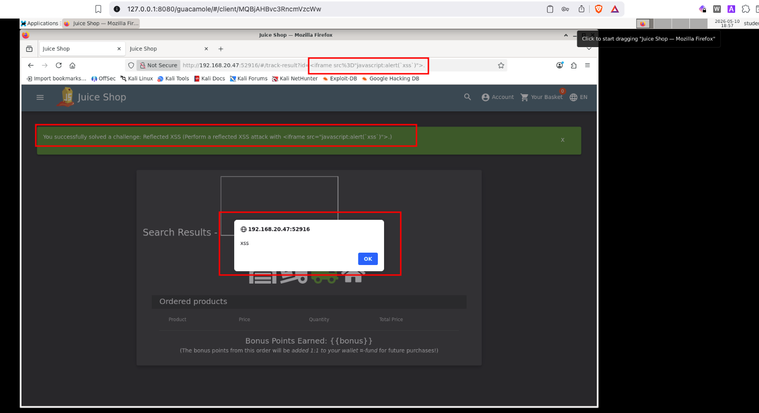
Figure 10: DOM XSS Successfully found and exploited

CVSS 3.1 Score

Field | Value
Vector string | https://nvd.nist.gov/vuln-metrics/cvss/v3-calculator?vector=AV:N/AC:L/PR:L/UI:R/S:U/C:H/I:H/A:H&version=3.1
Base score | 8.0
Severity | High

This vulnerability is set to high as CIA impact to this issue is high as a complete account takeover is possible for this scenario as the web application does not store the session cookies as HTTPOnly .

Remediation

- Primary fix - Input validation and output encoding are primarily need to fix XSS issues in general. Unsafe DOM function must be avoided.

References
- https://clouddocs.f5.com/training/community/waf/html/waf2023/module1/lab2.html

4. Summary Table
ID | Title | Target | Severity | CVSS Score
F-01 | Broken Session & Authentication Management | Target 2 | Medium | 5.4
F-02 | DOM XSS | Target 1 | High | 8.0

